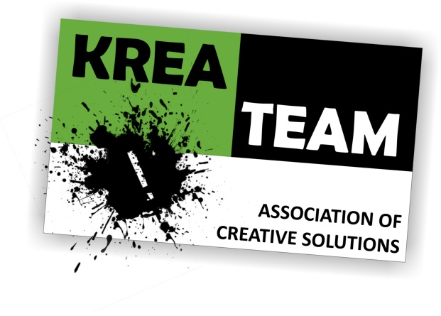
PARTNER INFORMATION FORM

Partner Organisation
PIC | 943249632
Full legal name (National Language) | Kreateam Egyesület
Address | Maklári u. 67.
Country | Hungary
Region | --
P.O. Box | --
Post Code | H-3300
City | Eger
Website | www.kreateam-ngo.org
Email | hello@kreateam-ngo.org
Telephone 1 | +36-36-788-949
Telephone 2 | +36-70-341-5702

Legal Representative
Title | Mrs.
Gender | Female
First Name | Andrea
Family Name | Dér-Herendovics
Department | --
Position | president
Email | hello@kreateam-ngo.org
Telephone 1 | +36-36-788-949

Type of Organisation
Is the partner organisation a public body? | No
Is the partner organisation a non-profit? | Yes
Activity level | International

Brief presentation of our organisation.
We are an experienced NGO from Hungary dealing with education management and adult education. We have several projects dealing with distance education, e-learning and competence development. One of our main aim is to give opportunities for young adults to implement their job ideas and other notions. The main function of the KreaTeam Association is to focus on the opportunities for young people (NEETs) and adults to provide services that promote the expansion of the knowledge of them in the fields of community building, skills development, dealing with the impact of EU integration etc…. To achieve the objectives of the Association we encountered resources, carry out trainings, organize events and projects. To achieve the objectives of the Association we work together public, social and economic organizations, associations to help the successful operation of the Association, and its target groups.

The main functions of the Association:
- Improves literacy of young people to promote life;
- Organizes youth and adult educational events;
- Helps EU integration of young people;
- Support for competence development mainly through e-learning
- Helps to create dialogs between the different age groups and generations to mitigate conflicts, and to strengthen the cohesion;
- Organizes camps, community-building programs;
- Helps the career of study of the youth and organizes educational trips;
- Helps the boosting of community life;
- Organizes and manages recreational programs;
- Builds relations with other youth organizations and scientific institutions, universities, colleges;
- Organizes competence development trainings, courses
- Organizes events where young talents have opportunity for showing himself;
- Supports scientific research, analyzes initiates, conducts, publishes professional publications
- Explores national and EU funds, writes proposals and initiate projects to the effective implementation the purposes of the Association.

Activities and experience of the organization
We are very active in the field of youth and adult education as holders but also as partners of different kind of projects in our country and abroad. The key for us is to work on both local and international projects and we try to cover broad scale of themes and topics according to what our target group finds interesting. We focus mainly on youth participation, intercultural understanding, active citizenship, entrepreneurship, sport, healthy lifestyle, community development, e-learning but also art and culture. The activities of our organisation are based on the approaches of non-formal education, experiential and intercultural learning, social inclusion and active participation. Our activities include but are not limited to: networking and cooperation; educational projects of different types (e.g. youth exchanges, training courses, seminars, workshops etc); awareness raising and policy development; capacity building; coaching of initiatives, organisational and individual coaching; mobility.
Main projects of the last years:
- Develop the lifeskills and financial literacy of NEEts (people who are Not in Education, Employment or Training).
- Searching my fund seminars – Workshops for young leaders of Hungary, who want to learn about tenders, and grants in the field of youth.
- Building community – projects of informal youth groups who are managing community spaces, and would like to develop their work.
- Coach program of youth workers – Seminars and workshops for Hungarian youth leaders dealing with project management, community development, youth participation and entrepreneurship.
- International youth exchanges – we were the partner of several youth exchange programs as trainers of non-formal education methods.
- Support for e-learning – introduction of a new method of competence development through e-learning
- Strategic partnerships in the field of adult education.

Informations on the key staff/persons and on the competences and previous experience that they will bring to the projects:
In order to ensure a quality project our organisation will involve expert and adequate staff members in the project from preparation, throughout implementation, exploitation, monitoring and evaluation to dissemination and follow-up. With experience in European and national project management the Kreateam Association will contribute to a sufficient project delivery providing an experienced project manager, project assistant, administrative and communication staff member.

The group of professionals, educators and youth workers who work with Kreateam have long experience in community development and in general in the conduct of educational activities for young people and adults. They also have specific expertise with group dynamics, conflict resolution, creative and educative activities, and non-formal learning methods.

Person responsible for the projects
Title | Mr
Gender | Male
First Name | Attila
Family Name | Dér
Position | coordinator
Email | hello@kreateam-ngo.org
Telephone 1 | +36-70-341-5702

